Operating System All Practicals
Practical 5
Write a program to deomnstare mutual exclusion and critical section.
public class MutualCritical {
public static void main(String[] args) {
MutualCritical mc = new MutualCritical();
new Thread(()->{
mc.criticalSection();
}).start();
new Thread(()->{
mc.criticalSection();
}).start();
}
public synchronized void criticalSection() {
System.out.println("In critical section");
try {
Thread.sleep(1000);
} catch (InterruptedException e) {
e.printStackTrace();
}
System.out.println("Out of critical section");
}
}

Output
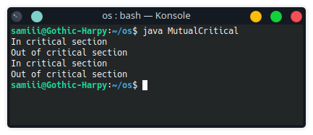

Practical 6
Implement producer consumer program.
public class producerConsumer {
boolean produced = false;
public void produce() throws Exception {
if (produced) {
System.err.println("Producer: Already produced. Waiting for consumer to consume.");
return;
}
System.out.println("Producer: Producing...");
Thread.sleep(2000);
produced = true;
System.out.println("Producer: Produced.");
}

public void consume() throws Exception {
if (!produced) {
System.err.println("Consumer: Nothing to consume. Waiting for producer to produce.");
return;
}
System.out.println("Consumer: Consuming...");
Thread.sleep(2000);
produced = false;
System.out.println("Consumer: Consumed.");
}
public static void main(String[] args) throws Exception {
producerConsumer pc = new producerConsumer();
pc.produce();
pc.consume();
pc.consume();
}
}
Output:
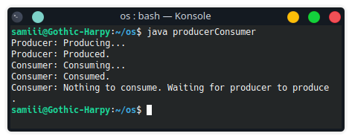
Practical 7
Implement program for reader and writer problem.
public class ReaderWriter {
boolean itemWrote, itemRead, isWriting, isReading;
public static void main(String[] args) throws Exception {
ReaderWriter rw=new ReaderWriter();
rw.writer();
rw.reader();
}
public ReaderWriter() {
this.itemWrote = false;
this.itemRead = false;
}
public void writer() throws Exception {
if (this.isReading || this.isWriting) {
System.err.println("Writer: Cant write whiole reader or writer is active.");
return;
}
this.isWriting = true;
Thread.sleep(2000);
this.itemWrote = true;
this.isWriting = false;
System.out.println("Writer: Writing is done..");

}
public void reader() throws Exception {
if (this.isWriting) {
System.err.println("Reader: Cant read while writer is active.");
return;
}
if (!this.itemWrote) {
System.err.println("Reader: Nothing to read");
return;
}
this.isReading = false;
Thread.sleep(2000);
this.itemRead = true;
System.err.println("Reader: Reading is done.");
this.isReading = false;
}

}
Output:

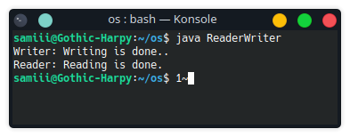
Practical 8
Program to demonstrate CPU scheduling algorithm.
public class fcfs {
public static void main(String[] args) {
int[] process={0,1,2,3,4,5,6,7,8,9};
int[] arrival={0,1,2,3,4,5,6,7,8,9};
int[] burst={1,2,3,4,5,6,7,8,9,10};
int[] completion=new int[10];
int[] waiting=new int[10];
int[] turnaround=new int[10];
int[] temp=new int[10];
int total=0;
int n=10;
for(int i=0;i<n;i++){
temp[i]=burst[i];
}
for(int i=0;i<n;i++){
total+=burst[i];
completion[i]=total;
}
for(int i=0;i<n;i++){
turnaround[i]=completion[i]-arrival[i];
waiting[i]=turnaround[i]-temp[i];
}
System.out.println("Process|Arrival|Burst|Completion|Turnaround|Waiting");
for(int i=0;i<n;i++){
System.out.println(" "+process[i]+"\t "+arrival[i]+"\t "+temp[i]+"\t "+completion[i]+"\t "+turnaround[i]+"\t "+waiting[i]);
}
}
}

Output.java
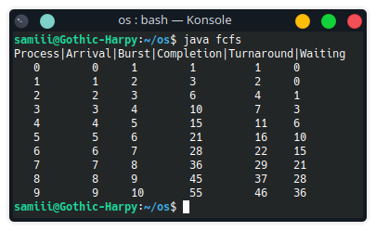

Practical 9
Implement program to demonstrate deadlock detection.
public class deadlockDetection {
public static void main(String[] args) throws Exception{
//Boolean.TRUE means any resource 1
//Boolean.FALSE means any resource 2
Thread thread1 = new Thread(() -> {
synchronized (Boolean.TRUE) {
System.out.println("Thread 1 acquired resource 1");
synchronized (Boolean.FALSE) {
System.out.println("Thread 1 acquired resource 2");
}
}
});
Thread thread2 = new Thread(() -> {
synchronized (Boolean.FALSE) {
System.out.println("Thread 2 acquired resource 2");
synchronized (Boolean.TRUE) {
System.out.println("Thread 2 acquired resource 1");
}
}
});
thread1.start();
thread2.start();
Thread.sleep(1000);
if(thread1.isAlive()&& thread2.isAlive()){
System.out.println("Deadlock detected");
}
else{
System.out.println("Deadlock not detected");
}
}
}
Output:
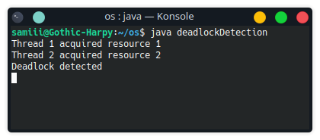

Practical 10
Imlpement program to demonstrate page replacement algorithm.
public class PageReplacement {
public static void main(String[] args) {
int[] pages = {1,2,3,4,1,2,5,1,2,3,4,5};
int[] frames = new int[3];
int pageFaults = 0;
int n = pages.length;
for(int i=0; i<n; i++){
boolean pageFound = false;
for(int j=0; j<frames.length; j++){
if(frames[j] == pages[i]){
pageFound = true;
break;
}
}
if(!pageFound){
int minIndex = 0;
int minCount = Integer.MAX_VALUE;
for(int j=0; j<frames.length; j++){
int count = 0;
for(int k=i-1; k>=0; k--){
if(frames[j] == pages[k]){
break;
}
count++;
}
if(count < minCount){
minIndex = j;
minCount = count;
}
}
frames[minIndex] = pages[i];
pageFaults++;
}
}
System.out.println("Page Faults: " + pageFaults);
}
}
Output:
